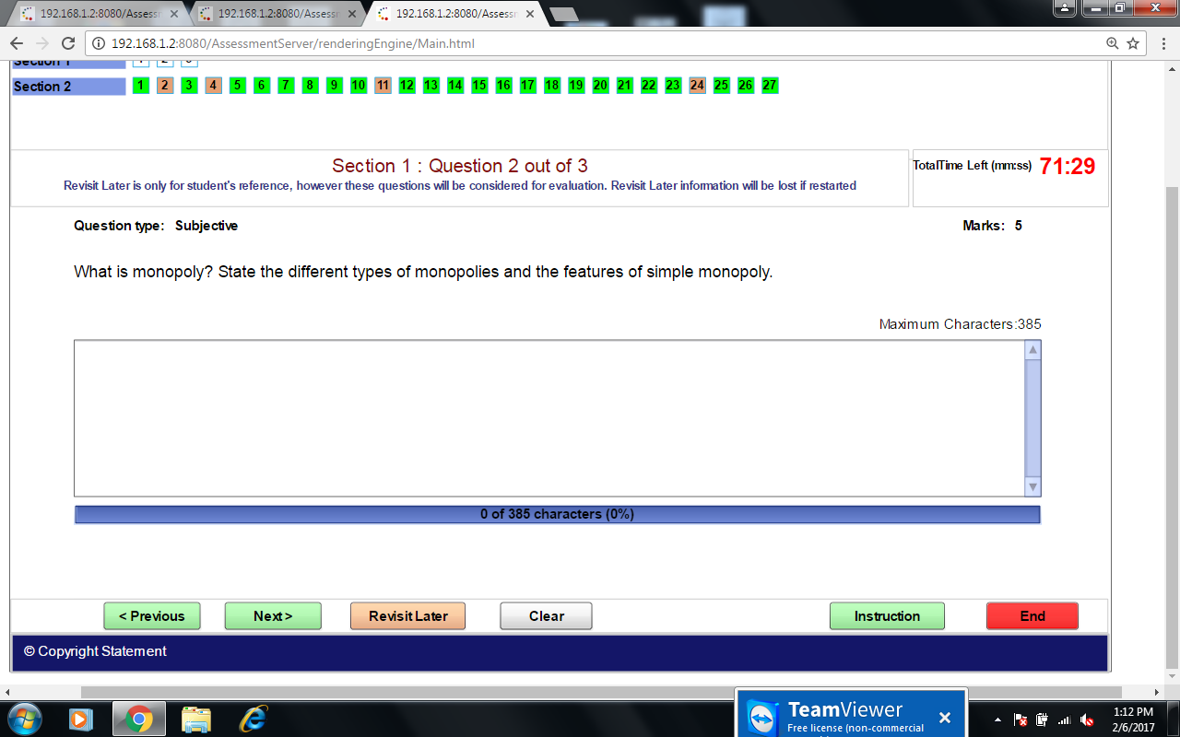 A market structure characterized by a single seller, selling a unique product in the market. In a monopoly market, the seller faces no competition, as he is the sole seller of goods with no close substitute.
Monopoly is of following kinds:
- Simple Monopoly and Discriminating Monopoly:
- Pure Monopoly and Imperfect Monopoly: ...
- Natural Monopoly: ...
- Legal Monopoly: ...
- Industrial Monopolies or Public Monopolies:

Features of a Monopoly Market
- Single Seller of the Product.
- Entry Restrictions.
- No Close Substitutes. ...
- Price Maker.
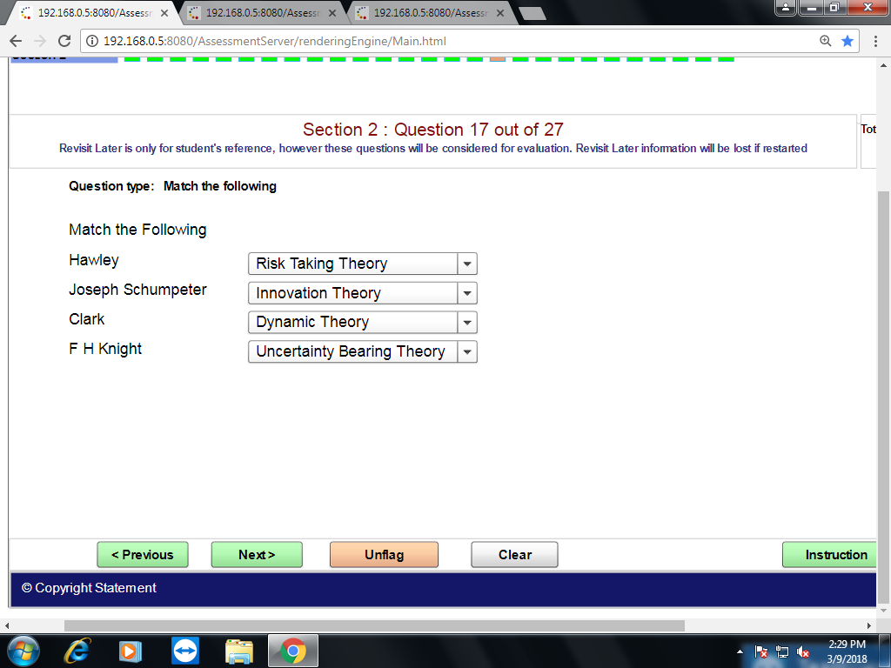

- Under cost plus pricing
 Actual costs are include
- Opportunity cost in included
- Certain percentage of profit included
 Implicit cost is included

- Causes for rise in prices in India are
 Increase in money supply
- Mounting government expenditure
- Decrease in aggregate supply
- Black money

- Welfare economics deals with problem such as
 Disguised unemployment
- Efficiency of production
- International relations
- Efficiency of allocation

- The typical objectives of a firm while fixing pricing policy are
 Market share
- Profitability
- Stability of price
- Target return on capital

